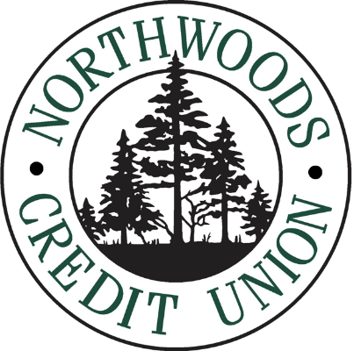
89th Annual Meeting
Tuesday, May 5th, 2026
Meeting details to come.

2026 Election for the Board of Directors

There are (2), 3 – year terms on the Northwoods Credit Union Board of Directors up for election in 2026 and the process for being placed on the ballot has begun.

The two seats up for election are currently held by our Board of Directors Larry Champeaux and Christine Ringat. Our Bylaws provide that there are no nominations from the floor of the annual meeting if there is at least one nominee for each position up for election. If you wish to be placed into nomination by the Nominating Committee, you must follow the process outlined below.

The Nominating Committee is currently accepting applications for nomination through 5:00pm Friday, 1/16/2025 (the application form can be found on our website). The form will ask you for a statement of qualifications and biographical data.

You can submit your application by completing online through the Board of Directors page and clicking submit. If you would like an alternative way of completing the application, please email NominatingCommittee@nothwoodscu.org.

Should you miss the 1/16/2025 deadline for submitting your application for nomination to the Nominating Committee, you will have the option to be placed on the ballot by petition signed by at least 1% of the membership (the deadline for submission of a nominating petition is 3/26/2025). More information about the nomination by petition process will be provided to the membership in February 2026.

Voting will take place at the Annual Meeting if there are more candidates than seats open for election (winners are determined by the three candidates gaining most votes, you do not run against a particular person).

The Bylaws also provide that the Supervisory Committee members are appointed by the Board of Directors and are not elected to the committee.

Northwoods Credit Union
1702 Avenue B, Cloquet MN 55720
www.northwoodscu.org · 1-888-458-097

